ST10021259

Assignment 2

INSY7213

Script:

-- CUSTOMER TABLE

CREATE TABLE CUSTOMER (

CUSTOMER_ID NUMBER PRIMARY KEY,

FIRST_NAME VARCHAR2(50) NOT NULL,

SURNAME VARCHAR2(50) NOT NULL,

ADDRESS VARCHAR2(100),

CONTACT_NUMBER VARCHAR2(20),

EMAIL VARCHAR2(100)

);

-- EMPLOYEE TABLE

CREATE TABLE EMPLOYEE (

EMPLOYEE_ID VARCHAR2(10) PRIMARY KEY,

FIRST_NAME VARCHAR2(50) NOT NULL,

SURNAME VARCHAR2(50) NOT NULL,

CONTACT_NUMBER VARCHAR2(20),

ADDRESS VARCHAR2(100),

EMAIL VARCHAR2(100)

);

-- DONATOR TABLE

CREATE TABLE DONATOR (

DONATOR_ID NUMBER PRIMARY KEY,

FIRST_NAME VARCHAR2(50) NOT NULL,

SURNAME VARCHAR2(50) NOT NULL,

CONTACT_NUMBER VARCHAR2(20),

EMAIL VARCHAR2(100)

);

-- DONATION TABLE

CREATE TABLE DONATION (

DONATION_ID NUMBER PRIMARY KEY,

DONATOR_ID NUMBER NOT NULL,

DONATION VARCHAR(50),

DONATION_PRICE NUMBER(10,2),

DONATION_DATE DATE,

CONSTRAINT FK_DONATOR FOREIGN KEY (DONATOR_ID)

REFERENCES DONATOR(DONATOR_ID)

);

-- DELIVERY TABLE

CREATE TABLE DELIVERY (

DELIVERY_ID NUMBER PRIMARY KEY,

DELIVERY_NOTES VARCHAR2(255),

DISPATCH_DATE DATE,

DELIVERY_DATE DATE

);

-- RETURNS TABLE

CREATE TABLE RETURNS (

RETURN_ID VARCHAR2(10) PRIMARY KEY,

RETURN_DATE DATE,

REASON VARCHAR2(255),

CUSTOMER_ID NUMBER,

DONATION_ID NUMBER,

EMPLOYEE_ID VARCHAR2(10),

CONSTRAINT FK_RETURN_CUSTOMER FOREIGN KEY (CUSTOMER_ID)

REFERENCES CUSTOMER(CUSTOMER_ID),

CONSTRAINT FK_RETURN_DONATION FOREIGN KEY (DONATION_ID)

REFERENCES DONATION(DONATION_ID),

CONSTRAINT FK_RETURN_EMPLOYEE FOREIGN KEY (EMPLOYEE_ID)

REFERENCES EMPLOYEE(EMPLOYEE_ID)

);

-- INVOICE TABLE

CREATE TABLE INVOICE (

INVOICE_NUM NUMBER PRIMARY KEY,

CUSTOMER_ID NUMBER,

INVOICE_DATE DATE,

EMPLOYEE_ID VARCHAR2(10),

DONATION_ID NUMBER,

DELIVERY_ID NUMBER,

CONSTRAINT FK_INVOICE_CUSTOMER FOREIGN KEY (CUSTOMER_ID)

REFERENCES CUSTOMER(CUSTOMER_ID),

CONSTRAINT FK_INVOICE_EMPLOYEE FOREIGN KEY (EMPLOYEE_ID)

REFERENCES EMPLOYEE(EMPLOYEE_ID),

CONSTRAINT FK_INVOICE_DONATION FOREIGN KEY (DONATION_ID)

REFERENCES DONATION(DONATION_ID),

CONSTRAINT FK_INVOICE_DELIVERY FOREIGN KEY (DELIVERY_ID)

REFERENCES DELIVERY(DELIVERY_ID)

);

-- INSERT SAMPLE DATA (MATCHES TABLE STRUCTURE)

-- CUSTOMER

INSERT ALL

INTO CUSTOMER (CUSTOMER_ID, FIRST_NAME, SURNAME, ADDRESS, CONTACT_NUMBER, EMAIL)

VALUES (11011, 'Jack', 'Smith', '18 Water Rd', '0877277521', 'jsmith@isat.com')

INTO CUSTOMER (CUSTOMER_ID, FIRST_NAME, SURNAME, ADDRESS, CONTACT_NUMBER, EMAIL)

VALUES (11012, 'Pat', 'Hendrix', '22 Water Road', '0863257857', 'ph@mcom.co.za')

INTO CUSTOMER (CUSTOMER_ID, FIRST_NAME, SURNAME, ADDRESS, CONTACT_NUMBER, EMAIL)

VALUES (11013, 'Andre', 'Clark', '101 Summer Lane', '08345767891', 'aclark@mcom.co.za')

INTO CUSTOMER (CUSTOMER_ID, FIRST_NAME, SURNAME, ADDRESS, CONTACT_NUMBER, EMAIL)

VALUES (11014, 'Kevin', 'Jones', '55 Mountain Way', '0612547895', 'kj@isat.co.za')

INTO CUSTOMER (CUSTOMER_ID, FIRST_NAME, SURNAME, ADDRESS, CONTACT_NUMBER, EMAIL)

VALUES (11015, 'Lucy', 'Williams', '5 Main Road', '0827238521', 'lw@mcal.co.za')

SELECT * FROM dual;

-- EMPLOYEE

INSERT ALL

INTO EMPLOYEE (EMPLOYEE_ID, FIRST_NAME, SURNAME, CONTACT_NUMBER, ADDRESS, EMAIL)

VALUES ('emp101', 'Jeff', 'Davis', '0877277521', '10 main road', 'jand@isat.com')

INTO EMPLOYEE (EMPLOYEE_ID, FIRST_NAME, SURNAME, CONTACT_NUMBER, ADDRESS, EMAIL)

VALUES ('emp102', 'Kevin', 'Marks', '0837377522', '18 Water Road', 'km@isat.com')

INTO EMPLOYEE (EMPLOYEE_ID, FIRST_NAME, SURNAME, CONTACT_NUMBER, ADDRESS, EMAIL)

VALUES ('emp103', 'Adania', 'Andrews', '081711-7523', '21 Circle Lane', 'aa@isat.com')

INTO EMPLOYEE (EMPLOYEE_ID, FIRST_NAME, SURNAME, CONTACT_NUMBER, ADDRESS, EMAIL)

VALUES ('emp104', 'Adebayo', 'Dryer', '0797215244', '1 sea Road', 'aryer@isat.com')

INTO EMPLOYEE (EMPLOYEE_ID, FIRST_NAME, SURNAME, CONTACT_NUMBER, ADDRESS, EMAIL)

VALUES ('emp105', 'Xolani', 'Samson', '082712-2255', '12 Main Road', 'xosam@isat.com')

SELECT * FROM dual;

-- DONATOR

INSERT ALL

INTO DONATOR (DONATOR_ID, FIRST_NAME, SURNAME, CONTACT_NUMBER, EMAIL)

VALUES (20111, 'Jeff', 'Watson', '0827172250', 'jwatson@ymail.com')

INTO DONATOR (DONATOR_ID, FIRST_NAME, SURNAME, CONTACT_NUMBER, EMAIL)

VALUES (20112, 'Stephan', 'Jones', '0837865670', 'joness@ymail.com')

INTO DONATOR (DONATOR_ID, FIRST_NAME, SURNAME, CONTACT_NUMBER, EMAIL)

VALUES (20113, 'James', 'Joe', '0878978650', 'jj@isat.com')

INTO DONATOR (DONATOR_ID, FIRST_NAME, SURNAME, CONTACT_NUMBER, EMAIL)

VALUES (20114, 'Kelly', 'Ross', '8026575650', 'kross@gsat.com')

INTO DONATOR (DONATOR_ID, FIRST_NAME, SURNAME, CONTACT_NUMBER, EMAIL)

VALUES (20115, 'Abraham', 'Clark', '8797656430', 'aclark@ymail.com')

SELECT * FROM dual;

-- DONATION

INSERT ALL

INTO DONATION (DONATION_ID, DONATOR_ID, DONATION, DONATION_PRICE, DONATION_DATE)

VALUES (7111, 20111, 'KIC Fridge', 599.00, TO_DATE('01-05-2024', 'DD-MM-YYYY'))

INTO DONATION (DONATION_ID, DONATOR_ID, DONATION, DONATION_PRICE, DONATION_DATE)

VALUES (7112, 20112, 'Samsung 42-inch LCD', 1299.00, TO_DATE('03-05-2024', 'DD-MM-YYYY'))

INTO DONATION (DONATION_ID, DONATOR_ID, DONATION, DONATION_PRICE, DONATION_DATE)

VALUES (7113, 20113, 'Sharp Microwave', 1599.00, TO_DATE('03-05-2024', 'DD-MM-YYYY'))

INTO DONATION (DONATION_ID, DONATOR_ID, DONATION, DONATION_PRICE, DONATION_DATE)

VALUES (7114, 20115, '6 seat dining room table', 799.00, TO_DATE('05-05-2024', 'DD-MM-YYYY'))

INTO DONATION (DONATION_ID, DONATOR_ID, DONATION, DONATION_PRICE, DONATION_DATE)

VALUES (7115, 20114, 'Lazy Boy Sofa', 1199.00, TO_DATE('07-05-2024', 'DD-MM-YYYY'))

INTO DONATION (DONATION_ID, DONATOR_ID, DONATION, DONATION_PRICE, DONATION_DATE)

VALUES (7116, 20113, 'JVC Surround Sound System', 179.00, TO_DATE('09-05-2024', 'DD-MM-YYYY'))

SELECT * FROM dual;

-- DELIVERY

INSERT ALL

INTO DELIVERY (DELIVERY_ID, DELIVERY_NOTES, DISPATCH_DATE, DELIVERY_DATE)

VALUES (511, 'Double packaging requested', TO_DATE('10-05-2024','DD-MM-YYYY'), TO_DATE('15-05-2024','DD-MM-YYYY'))

INTO DELIVERY (DELIVERY_ID, DELIVERY_NOTES, DISPATCH_DATE, DELIVERY_DATE)

VALUES (512, 'Delivery to work address', TO_DATE('12-05-2024','DD-MM-YYYY'), TO_DATE('15-05-2024','DD-MM-YYYY'))

INTO DELIVERY (DELIVERY_ID, DELIVERY_NOTES, DISPATCH_DATE, DELIVERY_DATE)

VALUES (513, 'Signature required', TO_DATE('12-05-2024','DD-MM-YYYY'), TO_DATE('17-05-2024','DD-MM-YYYY'))

INTO DELIVERY (DELIVERY_ID, DELIVERY_NOTES, DISPATCH_DATE, DELIVERY_DATE)

VALUES (514, NULL, TO_DATE('12-05-2024','DD-MM-YYYY'), TO_DATE('15-05-2024','DD-MM-YYYY'))

INTO DELIVERY (DELIVERY_ID, DELIVERY_NOTES, DISPATCH_DATE, DELIVERY_DATE)

VALUES (515, 'Birthday present wrapping required', TO_DATE('18-05-2024','DD-MM-YYYY'), TO_DATE('19-05-2024','DD-MM-YYYY'))

INTO DELIVERY (DELIVERY_ID, DELIVERY_NOTES, DISPATCH_DATE, DELIVERY_DATE)

VALUES (516, 'Delivery to work address', TO_DATE('20-05-2024','DD-MM-YYYY'), TO_DATE('25-05-2024','DD-MM-YYYY'))

SELECT * FROM dual;

-- RETURNS

INSERT ALL

INTO RETURNS (RETURN_ID, RETURN_DATE, REASON, CUSTOMER_ID, DONATION_ID, EMPLOYEE_ID)

VALUES ('ret001', TO_DATE('25-05-2024','DD-MM-YYYY'), 'Customer not satisfied with product', 11011, 7116, 'emp101')

INTO RETURNS (RETURN_ID, RETURN_DATE, REASON, CUSTOMER_ID, DONATION_ID, EMPLOYEE_ID)

VALUES ('ret002', TO_DATE('25-05-2024','DD-MM-YYYY'), 'Product had broken section', 11013, 7114, 'emp103')

SELECT * FROM dual;

-- INVOICE TABLE - INSERT ALL SAMPLE DATA

INSERT ALL

INTO INVOICE (INVOICE_NUM, CUSTOMER_ID, INVOICE_DATE, EMPLOYEE_ID, DONATION_ID, DELIVERY_ID)

VALUES (8111, 11011, TO_DATE('15-05-2024','DD-MM-YYYY'), 'emp103', 7111, 511)

INTO INVOICE (INVOICE_NUM, CUSTOMER_ID, INVOICE_DATE, EMPLOYEE_ID, DONATION_ID, DELIVERY_ID)

VALUES (8112, 11013, TO_DATE('15-05-2024','DD-MM-YYYY'), 'emp101', 7114, 512)

INTO INVOICE (INVOICE_NUM, CUSTOMER_ID, INVOICE_DATE, EMPLOYEE_ID, DONATION_ID, DELIVERY_ID)

VALUES (8113, 11012, TO_DATE('17-05-2024','DD-MM-YYYY'), 'emp101', 7112, 513)

INTO INVOICE (INVOICE_NUM, CUSTOMER_ID, INVOICE_DATE, EMPLOYEE_ID, DONATION_ID, DELIVERY_ID)

VALUES (8114, 11015, TO_DATE('17-05-2024','DD-MM-YYYY'), 'emp102', 7113, 514)

INTO INVOICE (INVOICE_NUM, CUSTOMER_ID, INVOICE_DATE, EMPLOYEE_ID, DONATION_ID, DELIVERY_ID)

VALUES (8115, 11011, TO_DATE('17-05-2024','DD-MM-YYYY'), 'emp102', 7115, 515)

INTO INVOICE (INVOICE_NUM, CUSTOMER_ID, INVOICE_DATE, EMPLOYEE_ID, DONATION_ID, DELIVERY_ID)

VALUES (8116, 11015, TO_DATE('18-05-2024','DD-MM-YYYY'), 'emp103', 7116, 516)

SELECT * FROM dual;

-- COMMIT CHANGES

COMMIT;

--QUESTION 2:

SELECT

c.FIRST_NAME || ' ' || c.SURNAME AS CUSTOMER_NAME,

i.EMPLOYEE_ID,

d.DELIVERY_NOTES,

dn.DONATION AS DONATION_PURCHASED,

i.INVOICE_NUM,

TO_CHAR(i.INVOICE_DATE, 'DD-MON-YYYY') AS INVOICE_DATE

FROM

INVOICE i

JOIN CUSTOMER c ON i.CUSTOMER_ID = c.CUSTOMER_ID

JOIN EMPLOYEE e ON i.EMPLOYEE_ID = e.EMPLOYEE_ID

JOIN DELIVERY d ON i.DELIVERY_ID = d.DELIVERY_ID

JOIN DONATION dn ON i.DONATION_ID = dn.DONATION_ID

WHERE

i.INVOICE_DATE > TO_DATE('16-05-2024', 'DD-MM-YYYY')

ORDER BY

i.INVOICE_DATE;

--QUESTION 3:

-- 3.1. Create FUNDING table

CREATE TABLE FUNDING (

FUNDING_ID NUMBER PRIMARY KEY,

FUNDER VARCHAR2(100),

FUNDING_AMOUNT NUMBER(12,2)

);

-- 3.2. Create a sequence to auto-generate FUNDING_ID

CREATE SEQUENCE FUNDING_SEQ

START WITH 1

INCREMENT BY 1

NOCACHE

NOCYCLE;

--Create a trigger that will automatically set the FUNDING_ID on insert

CREATE OR REPLACE TRIGGER FUNDING_BI

BEFORE INSERT ON FUNDING

FOR EACH ROW

BEGIN

IF :NEW.FUNDING_ID IS NULL THEN

:NEW.FUNDING_ID := FUNDING_SEQ.NEXTVAL;

END IF;

END;

/

-- 3.3. Example insert statement (no need to provide FUNDING_ID manually)

INSERT INTO FUNDING (FUNDER, FUNDING_AMOUNT)

VALUES ('Global Aid Foundation', 50000.00);

-- COMMENT / JUSTIFICATION

-- Making use of a sequence with a BEFORE INSERT trigger makes it so that FUNDING_ID will be automatically generated

--QUESTION 4:

-- Display returns information using PL/SQL

SET SERVEROUTPUT ON;

DECLARE

v_customer_name VARCHAR2(100);

v_donation VARCHAR2(50);

v_price NUMBER(10,2);

v_reason VARCHAR2(255);

CURSOR returns_cursor IS

SELECT

c.FIRST_NAME || ' ' || c.SURNAME AS CUSTOMER_NAME,

d.DONATION,

d.DONATION_PRICE,

r.REASON

FROM

RETURNS r

JOIN CUSTOMER c ON r.CUSTOMER_ID = c.CUSTOMER_ID

JOIN DONATION d ON r.DONATION_ID = d.DONATION_ID

ORDER BY r.RETURN_ID;

BEGIN

FOR rec IN returns_cursor LOOP

DBMS_OUTPUT.PUT_LINE('Customer: ' || rec.CUSTOMER_NAME);

DBMS_OUTPUT.PUT_LINE('Donation Purchased: ' || rec.DONATION);

DBMS_OUTPUT.PUT_LINE('Price: R' || TO_CHAR(rec.DONATION_PRICE, '9999.99'));

DBMS_OUTPUT.PUT_LINE('Return Reason: ' || rec.REASON);

DBMS_OUTPUT.PUT_LINE('------------------------');

END LOOP;

END;

/

--QUESTION 5:

-- Display customer name, employee name, donation, dispatch and delivery dates with days between for customer 11011

SET SERVEROUTPUT ON;

DECLARE

v_customer_name VARCHAR2(100);

v_employee_name VARCHAR2(100);

v_donation VARCHAR2(50);

v_dispatch_date DATE;

v_delivery_date DATE;

v_days_to_delivery NUMBER;

CURSOR invoice_cursor IS

SELECT

c.FIRST_NAME || ' ' || c.SURNAME AS CUSTOMER_NAME,

e.FIRST_NAME || ' ' || e.SURNAME AS EMPLOYEE_NAME,

dn.DONATION,

d.DISPATCH_DATE,

d.DELIVERY_DATE,

(d.DELIVERY_DATE - d.DISPATCH_DATE) AS DAYS_TO_DELIVERY

FROM

INVOICE i

JOIN CUSTOMER c ON i.CUSTOMER_ID = c.CUSTOMER_ID

JOIN EMPLOYEE e ON i.EMPLOYEE_ID = e.EMPLOYEE_ID

JOIN DONATION dn ON i.DONATION_ID = dn.DONATION_ID

JOIN DELIVERY d ON i.DELIVERY_ID = d.DELIVERY_ID

WHERE

c.CUSTOMER_ID = 11011;

BEGIN

FOR rec IN invoice_cursor LOOP

DBMS_OUTPUT.PUT_LINE('Customer: ' || rec.CUSTOMER_NAME);

DBMS_OUTPUT.PUT_LINE('Employee: ' || rec.EMPLOYEE_NAME);

DBMS_OUTPUT.PUT_LINE('Donation: ' || rec.DONATION);

DBMS_OUTPUT.PUT_LINE('Dispatch Date: ' || TO_CHAR(rec.DISPATCH_DATE, 'DD-MON-YYYY'));

DBMS_OUTPUT.PUT_LINE('Delivery Date: ' || TO_CHAR(rec.DELIVERY_DATE, 'DD-MON-YYYY'));

DBMS_OUTPUT.PUT_LINE('Days to Delivery: ' || rec.DAYS_TO_DELIVERY);

DBMS_OUTPUT.PUT_LINE('------------------------');

END LOOP;

END;

/

--QUESTION 6:

DECLARE

v_customer_name VARCHAR2(100);

v_total_amount NUMBER(10,2);

v_rating VARCHAR2(20);

CURSOR customer_spending_cursor IS

SELECT

c.FIRST_NAME || ' ' || c.SURNAME AS CUSTOMER_NAME,

NVL(SUM(dn.DONATION_PRICE), 0) AS TOTAL_AMOUNT

FROM

CUSTOMER c

LEFT JOIN INVOICE i ON c.CUSTOMER_ID = i.CUSTOMER_ID

LEFT JOIN DONATION dn ON i.DONATION_ID = dn.DONATION_ID

GROUP BY

c.FIRST_NAME, c.SURNAME

ORDER BY

TOTAL_AMOUNT DESC;

BEGIN

FOR rec IN customer_spending_cursor LOOP

v_customer_name := rec.CUSTOMER_NAME;

v_total_amount := rec.TOTAL_AMOUNT;

-- Determine rating

IF v_total_amount >= 1500 THEN

v_rating := ' (3 stars)';

ELSE

v_rating := '';

END IF;

DBMS_OUTPUT.PUT_LINE('Customer Name: ' || v_customer_name);

DBMS_OUTPUT.PUT_LINE('Amount: R' || TO_CHAR(v_total_amount, '9999.99') || v_rating);

DBMS_OUTPUT.PUT_LINE('------------------------');

END LOOP;

DBMS_OUTPUT.PUT_LINE('PL/SQL procedure successfully completed.');

END;

/

--QUESTION 7:

--7.1 %TYPE Attribute

DECLARE

v_donation_price DONATION.DONATION_PRICE%TYPE; -- Uses %TYPE to match column data type

v_budget_limit DONATION.DONATION_PRICE%TYPE := 1000.00; -- Budget limit for comparison

v_donation_name DONATION.DONATION%TYPE; -- Stores donation name

BEGIN

-- Retrieve a specific donation's price and name

SELECT DONATION_PRICE, DONATION

INTO v_donation_price, v_donation_name

FROM DONATION

WHERE DONATION_ID = 7112;

DBMS_OUTPUT.PUT_LINE('Donation: ' || v_donation_name);

DBMS_OUTPUT.PUT_LINE('Price: R' || TO_CHAR(v_donation_price, '9999.99'));

-- Check if within budget

IF v_donation_price <= v_budget_limit THEN

DBMS_OUTPUT.PUT_LINE('Status: Within budget limit');

ELSE

DBMS_OUTPUT.PUT_LINE('Status: Exceeds budget limit by R' ||

TO_CHAR(v_donation_price - v_budget_limit, '9999.99'));

END IF;

END;

/

--7.2 %ROWTYPE Attribute

DECLARE

v_employee_record EMPLOYEE%ROWTYPE;

v_emp_id EMPLOYEE.EMPLOYEE_ID%TYPE := 'emp103';

BEGIN

SELECT *

INTO v_employee_record

FROM EMPLOYEE

WHERE EMPLOYEE_ID = v_emp_id;

-- Display all employee details

DBMS_OUTPUT.PUT_LINE('===== EMPLOYEE DETAILS =====');

DBMS_OUTPUT.PUT_LINE('Employee ID: ' || v_employee_record.EMPLOYEE_ID);

DBMS_OUTPUT.PUT_LINE('Full Name: ' || v_employee_record.FIRST_NAME || ' ' || v_employee_record.SURNAME);

DBMS_OUTPUT.PUT_LINE('Contact Number: ' || v_employee_record.CONTACT_NUMBER);

DBMS_OUTPUT.PUT_LINE('Address: ' || v_employee_record.ADDRESS);

DBMS_OUTPUT.PUT_LINE('Email: ' || v_employee_record.EMAIL);

DBMS_OUTPUT.PUT_LINE('============================');

END;

/

--7.3 User-Defined Exception

DECLARE

-- User-defined exception

e_invalid_delivery_dates EXCEPTION;

v_delivery_id DELIVERY.DELIVERY_ID%TYPE;

v_dispatch_date DELIVERY.DISPATCH_DATE%TYPE;

v_delivery_date DELIVERY.DELIVERY_DATE%TYPE;

v_notes DELIVERY.DELIVERY_NOTES%TYPE;

CURSOR delivery_cursor IS

SELECT DELIVERY_ID, DISPATCH_DATE, DELIVERY_DATE, DELIVERY_NOTES

FROM DELIVERY;

BEGIN

DBMS_OUTPUT.PUT_LINE('===== DELIVERY VALIDATION CHECK =====');

FOR rec IN delivery_cursor LOOP

v_delivery_id := rec.DELIVERY_ID;

v_dispatch_date := rec.DISPATCH_DATE;

v_delivery_date := rec.DELIVERY_DATE;

v_notes := rec.DELIVERY_NOTES;

-- Check if dispatch date is after delivery date (invalid scenario)

IF v_dispatch_date > v_delivery_date THEN

RAISE e_invalid_delivery_dates; -- Raise custom exception

END IF;

DBMS_OUTPUT.PUT_LINE('Delivery ID ' || v_delivery_id || ': Valid');

DBMS_OUTPUT.PUT_LINE(' Dispatch: ' || TO_CHAR(v_dispatch_date, 'DD-MON-YYYY'));

DBMS_OUTPUT.PUT_LINE(' Delivery: ' || TO_CHAR(v_delivery_date, 'DD-MON-YYYY'));

DBMS_OUTPUT.PUT_LINE(' Days taken: ' || (v_delivery_date - v_dispatch_date));

END LOOP;

DBMS_OUTPUT.PUT_LINE('All delivery dates validated successfully!');

DBMS_OUTPUT.PUT_LINE('=====================================');

EXCEPTION

WHEN e_invalid_delivery_dates THEN

DBMS_OUTPUT.PUT_LINE('ERROR: Invalid delivery dates detected!');

DBMS_OUTPUT.PUT_LINE('Delivery ID ' || v_delivery_id || ' has dispatch date after delivery date.');

DBMS_OUTPUT.PUT_LINE('Dispatch Date: ' || TO_CHAR(v_dispatch_date, 'DD-MON-YYYY'));

DBMS_OUTPUT.PUT_LINE('Delivery Date: ' || TO_CHAR(v_delivery_date, 'DD-MON-YYYY'));

DBMS_OUTPUT.PUT_LINE('Please correct the dates in the database.');

WHEN OTHERS THEN

DBMS_OUTPUT.PUT_LINE('Unexpected error: ' || SQLERRM);

END;

/

--QUESTION 8:

SELECT

c.FIRST_NAME,

c.SURNAME,

'R' || TO_CHAR(NVL(SUM(dn.DONATION_PRICE), 0), '9999.99') AS AMOUNT,

CASE

WHEN NVL(SUM(dn.DONATION_PRICE), 0) >= 1500 THEN '***'

WHEN NVL(SUM(dn.DONATION_PRICE), 0) BETWEEN 1000 AND 1499.99 THEN '**'

ELSE '*'

END AS CUSTOMER_RATING

FROM

CUSTOMER c

LEFT JOIN INVOICE i ON c.CUSTOMER_ID = i.CUSTOMER_ID

LEFT JOIN DONATION dn ON i.DONATION_ID = dn.DONATION_ID

GROUP BY

c.FIRST_NAME, c.SURNAME

ORDER BY

NVL(SUM(dn.DONATION_PRICE), 0) DESC;

Screenshots:

Create tables:

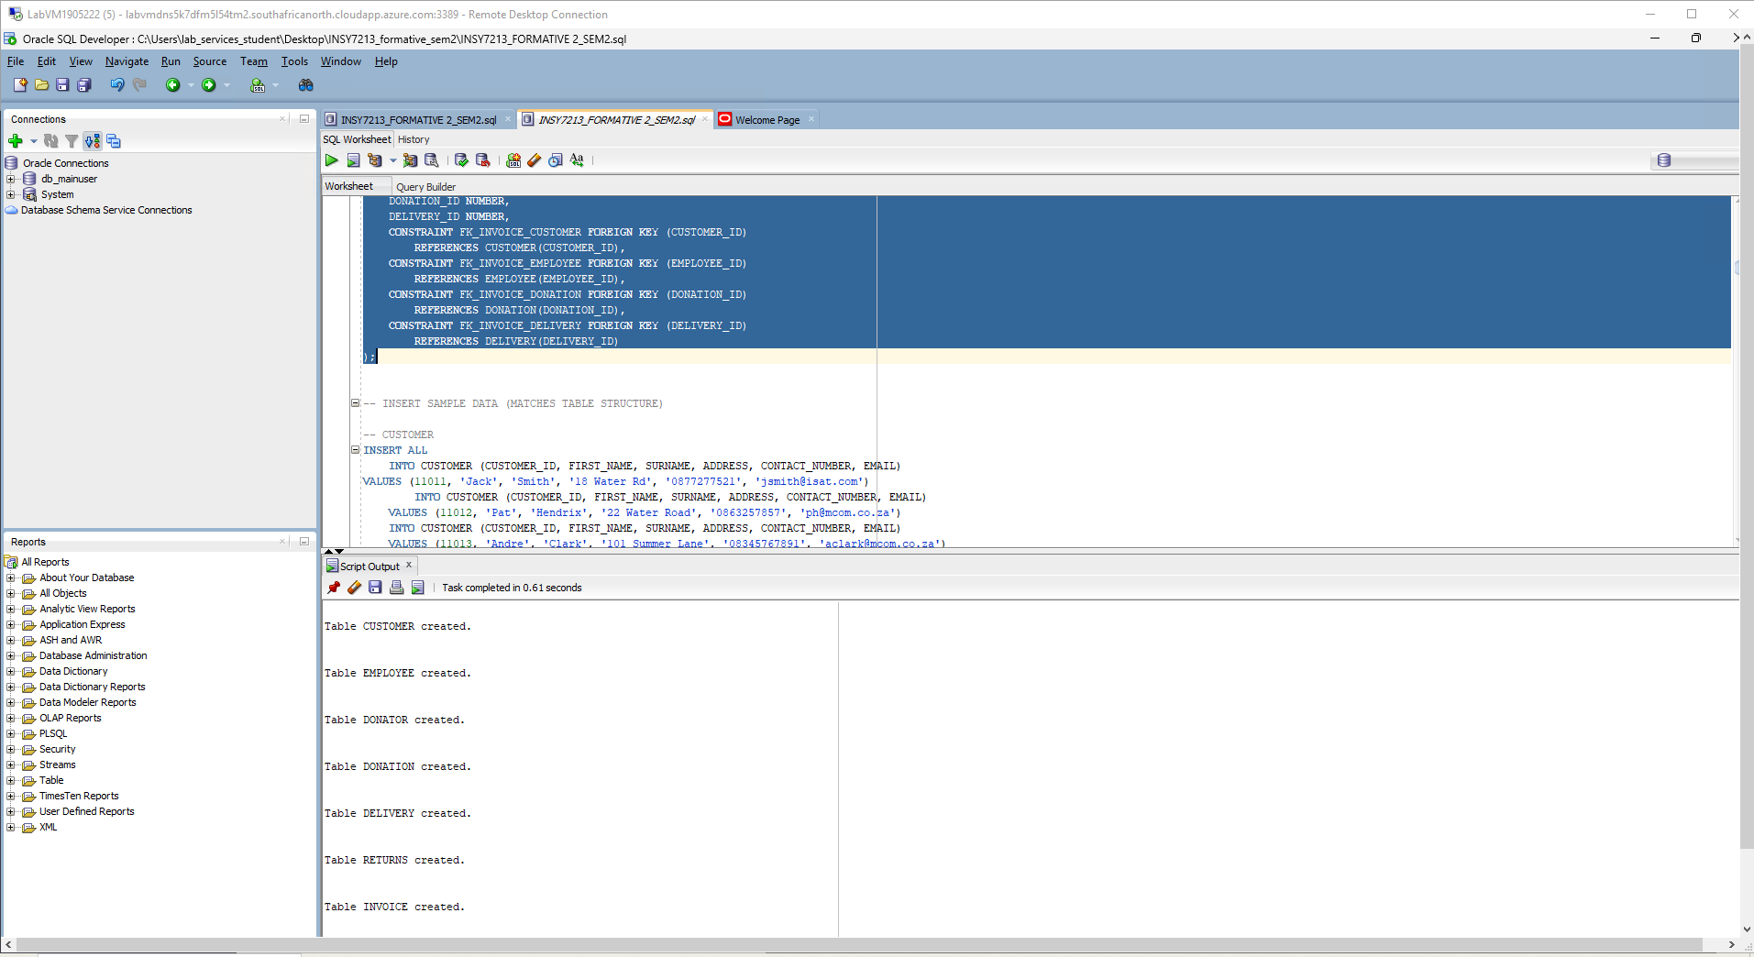

Insert data:

Question 2:

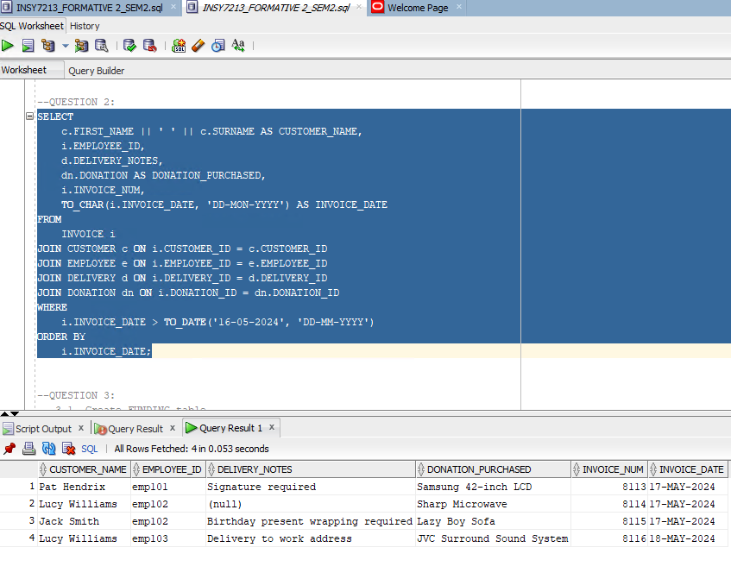

Question 3:

Question 4:

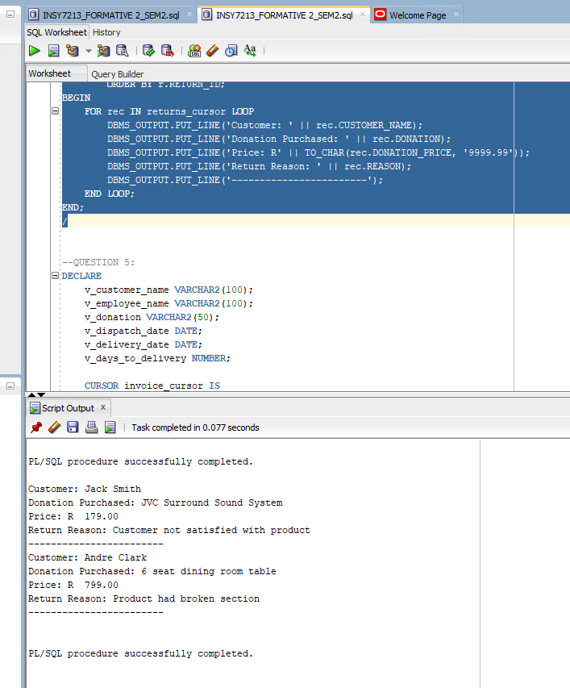

Question 5:

Question 6:

Question 7:

Question 8:

